# Always Encrypted README

The AdventureWorks database uses the [Always Encrypted](https://msdn.microsoft.com/en-us/library/mt163865.aspx) feature to protect sensitive information stored in the SSN and CreditCardNumber columns in the Sales.CustomerPII table. This file provides the steps to explore the capabilities of Always Encrypted and the encryption configruation in the database.

For information about Always Encrypted, please see:

* MSDN documentation: [Always Encrypted (Database Engine)](https://msdn.microsoft.com/en-us/library/mt163865.aspx)
* Always Encrypted articles on [SQL Server Security Blog](http://blogs.msdn.com/b/sqlsecurity/archive/tags/always+encrypted/)

1. Query encrypted columns without decrypting sensitive data:
   1. Using SSMS, connect to the database.
   2. Using Object Explorer, navigate to the Sales.CustomerPII table.
   3. Right-click on the table and choose **Select Top 1000 Rows**.
      1. The query should return binary values, e.g.: 0x01F7753C73CA15965E314…, in both the SSN and CreditCardNumber columns.
2. Query encrypted columns, attempting to decrypt sensitive data without having the valid column master key configured in your environment.
   1. Close the database connection from step 1 and reconnect by adding the following connection string keyword/value in the **Additional Connection Parameters** of the **Connect to Database Engine** dialog: **column encryption setting=enabled**.

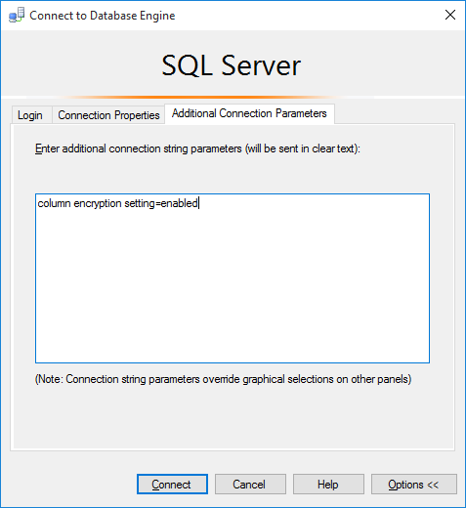

* 1. Using Object Explorer, navigate to the Sales.CustomerPII table.
  2. Right-click on the table and choose **Select Top 1000 Rows**.

The query is expected to fail, as you try to decrypt sensitive data stored in the SSN and CreditCardNumber columns, but you do not have the column master key, protecting those columns.

1. Query sensitive data columns, decrypting the results using a valid column master key configured in your environment.
   1. Import the certificate that is configured as a column master key in the database.
      1. Using Windows explorer, navigate and double click on the AlwaysEncryptedCMK.pfx file. This will open Certificate Import Wizard.

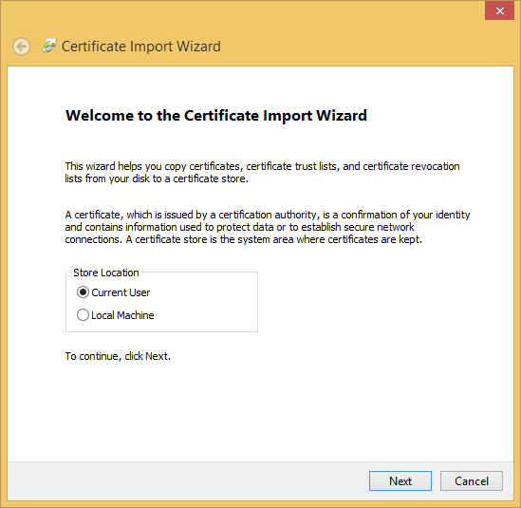

* + 1. Click **Next** (leave **Current User** selected for **Store Location**) and then **Next** again.
    2. Enter the password for the certificate: **AlwaysEncrypted**.

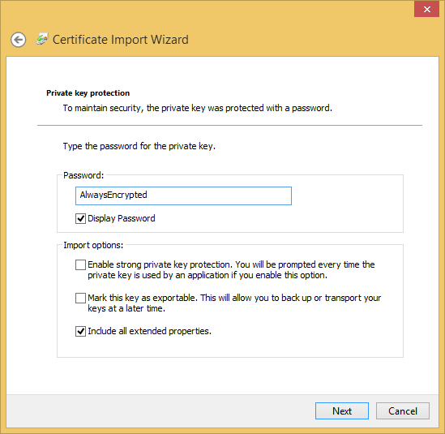

* + 1. Click **Next** and then click **Finish**.
  1. Make sure, you are connected to the database with **column encryption setting=enabled**. (please, see step 2a).
  2. Using Object Explorer, navigate to the Sales.CustomerPII table.
  3. Right-click on the table and choose **Select Top 1000 Rows**.

Since you can now access the certificate, used as a column master key in the database, the query should succeed and return plain text values stored in the SSN and CreditCardNumber columns.